CHALLENGES FACING GLOBAL GEOPOLITICAL SYSTEM’s STABILITY

Today, there are several threats to the global geopolitical system. These threats are against the Westphalian State System or the geopolitical stability of the world. These are:

1. Weak and Failed States;
2. Clash of Civilisations;
3. International economic inequalities;
4. Existence of global geopolitical hotspots.
5. ***Weak and Failed States:*** **Failed States, Enduring States, and Totalitarian States**

Basically, a state is considered as a sovereign state if it performs three major basic tasks: a) to have sovereign control over a given territory, b) to mobilise masses for needs of the state, as in collection of taxes or compulsory education, and c) to protect its subjects/citizens from internal and external threats against their lives, properties, and freedoms of thought and expression. However, states cover a very wide spectrum from totalitarian states to failed states in terms of their ability to control their public and the everyday developments in their countries.

A state is successful, that is *enduring*, if it holds a monopoly on the legitimate use of coercive physical force within its borders. When this monopoly is broken or threatened, the state’s existence is questionable because as the state loses its monopoly on use of coercive force, it begins to fail to lose a) its control based on use or threat of use of force over its subjects or citizens; b) its control over a given territory; and c) on its ability to collect taxes and provide the services expected to be provided by the state since the beginning of the twentieth century such as education, roads, health services and so on. In this case, one can categorise a state as a fragile, if not failed, state.

On the complete opposite end of the political spectrum from an enduring state, we can see the *failed state*. The *Crisis States Research Centre* defines a “failed state” as a state that can no longer perform its basic security and development functions and that has no effective control over its territory and borders. Therefore, a failed state is unable to reproduce the conditions for its own existence.

On the other hand, looking at the general characteristics of the failed and fragile states, it can be argued that the other end of the spectrum is the all-controlling *totalitarian* *state* as a failed state has no control over its territory and generally its citizens. Totalitarian rule can be defined as the extreme case in which state controls the lives of its people in nearly all politically significant areas of social, economic, and political life. It is therefore logical to think that totalitarian state is the antithesis of the failed state, however, it is possible to be a failed state and to have a totalitarian regime at the same time. That the regime has near complete control over the state institutions and coercive and ideological means does not mean that the ruling regime has a willingness to use these to legitimise itself or to improve the lives of its citizens. Uzbekistan is a clear example of this sort of failed state as can be seen below.

Antonio Gramsci emphasises a very crucial point when he states that the main mistake in politics arises from the misconception of the state as a monolithic organisation ruling with authority and sovereignty, because state does not rule only through the coercive forces; it makes use of ideology to prevent a counterrevolution. Therefore, the administration is not only coercive and/or limiting in terms of individual manoeuvring spaces, but also is hegemonic within the system it rules. To enjoy this hegemonic position more easily, each and every ruling regime uses different methods. Jean Baudrillard, Louis Althusser, and Michel Foucault have worked on these different methods and their application similar on theoretical framework but different in superstructure. According to Louis Althusser, there are two means state can exercise its authority and control over the masses: through the *repressive mechanism* and through the *ideological mechanism* of the state. When we look at the use of these means, perhaps, the major difference between a failed state and a state which functions properly becomes the clearest and most evident: The use of ideological mechanisms, such as institutions of education or of the mass media, reinforces the legitimacy of the state as well as its capacity to control its subjects/citizens. The problem with a failed, fragile, or crisis state arises from exactly this distinction, and not its inability to control the coercive means. In short, even a fragile state which is not necessarily a failed state, can fail to convince its subjects in terms of its legitimacy and its reasons for existence. This failure creates grave problems on the legitimacy of the state itself as opposed to questions about the legitimacy of the ruling order and its use of coercive means.

1. ***Clash of Civilizations:***

Francis Fukuyama had argued that as liberal democracy has won against socialism at the end of the Cold War, we came to the end of history. Samuel Huntington refused his former student Fukuyama’s ideas in his ***‘Clash of Civilizations’*** article which later became a book. Huntington believed the age of conflict did not end but was just beginning. He described *‘Fault lines’* of international politics and described six different civilizations which could fight with each other especially in these Fault Line regions. Fault lines are geopolitical areas where more than two regions with different cultural (civilizational) traditions meet but cannot be compatible with each other. This incompatibility creates tensions between the neighbouring civilizations. As a result, we have continuous conflicts and therefore the world is in fact a very unstable place. According to Huntington, and conflicts will not only continue but also become extremely violent both in military and social contexts. Huntington, therefore, put geopolitics into a new perspective. Instead of specific countries and their relations, he focused on civilizations (by which he actually means cultural traditions) and effects of these clashes would be very high. Regions and continents macro level and national regions in a micro level as part of Huntington’s *‘torn countries’* would be the geographic location of these conflicts.

According to Huntington, some countries are culturally consistent but are divided over whether their society belongs to one civilization or another. These are torn countries. Their leaders typically wish to pursue a strategy of following in the footsteps of another civilization and try to make their countries members of the West, but the history, culture and traditions of their countries are non-Western. The most obvious and prototypical torn country is Turkey. The late twentieth-century leaders of Turkey have followed in the Atatürk tradition and defined Turkey as a modern, secular, Western nation state. They allied Turkey with the West in NATO and in the Gulf War; they applied for membership in the European Union. At the same time, however, elements in Turkish society have supported an Islamic revival and have argued that Turkey is basically a Middle Eastern Muslim society. In addition, while the elite of Turkey has defined Turkey as a Western society, the elite of the West refuses to accept Turkey as such.

During the past decade Mexico has assumed a position somewhat similar to that of Turkey. Just as Turkey abandoned its historic opposition to Europe and attempted to join Europe, Mexico has stopped defining itself by its opposition to the United States and is instead attempting to imitate the United States and to join it in the North American Free Trade Area. Mexican leaders are engaged in the great task of redefining Mexican identity and have introduced fundamental economic reforms that eventually will lead to fundamental political change. Therefore, they try to change Mexico from a Latin American country to a “North American” country, creating geopolitical confusion. In Mexico as in Turkey, significant elements in society resist the redefinition of their country's identity. In Turkey, European-oriented leaders have to make gestures to Islam; so also Mexico's North American-oriented leaders have to make gestures to those who hold Mexico to be a Latin American country.

1. ***International Economic Inequalities:***

The theory of the Global North and Global South is a new geopolitical perspective. It divides the world into two blocs – the industrialized countries of the global North and the poor countries of the South on the global level of analysis. “Global South” is sometimes used as a synonym for the more familiar “third world” as that term is now unpopular. The North-South divide has more recently been named the development continuum gap. This places greater emphasis on closing the gap between rich (more economically developed) and poor (less economically developed) countries. A good measure of on which side of the gap a country is located is the Human Development Index (HDI). The North-South Divide term comes from former West German PM Willy Brandt who pointed out that developed countries were generally part of the Northern Hemisphere (especially above 30˚North in world map) while developing countries were part of the Southern Hemisphere. The Global South contains about three quarters of the world populations, but just one fifth of the world income. It lacks appropriate technology, political stability, and has mainly been a source of raw material for the North (Mimiko, 2012). Poverty in the region has not just led to a poor standard of living, but is also a major cause of violence and conflict.

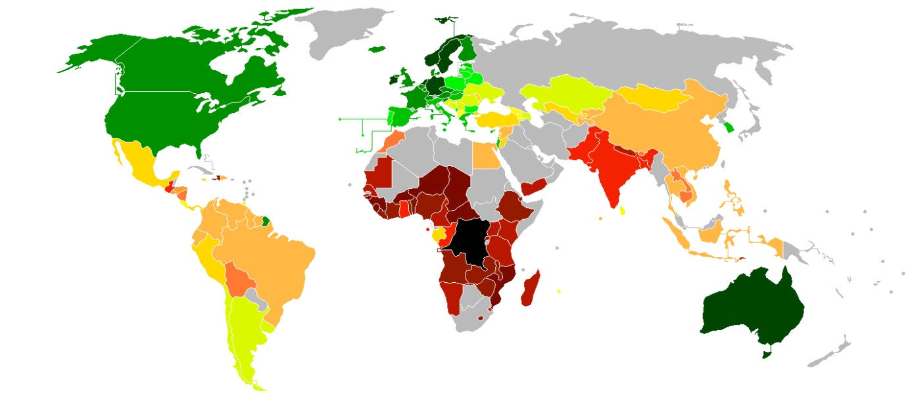

The map above shows the North-South divide including different income groups among countries of the World. Dark green shows the richest and dark brown the poorest countries.

1. Global Geopolitical Hotspots:

There are geopolitical locations on the World that are likely to create political, military, and economic problems among the great powers of the international system. These problems may be caused by economic inequalities, territorial disputes, weak and fragile states, ethnic, cultural, religious fault lines, and a clash of economic zones of influence. When we look at the world today, Ukraine, Western and Central Africa, South Asia, Southeast Asia, the Middle East are the possible or actual geopolitical fields of confrontation. These areas are called “geopolitical hotspots” and affect the normal functioning of global politics and economics. [Please read Chapter 3 of Bert Chapman’s book Geopolitics – A Guide to the Issues for further information on current and emerging (potential) geopolitical hotspots.]